Slack Conversations

NoteShare Project

SOEN341

**January 23, 2017**

Team members discussed their programming skills to help decide which programming language to use for the project.

Anthony Fiorito: C++, Java, Swift/Obj-C, HTML, CSS, JavaScript, NodeJS

Fozail Ahmad: C++, Java, C#

Francois Crispo-Sauve: C++, java, C#, HTML, CSS, JavaScript, PHP

Charbel Chahine: Java, HTML, CSS, Javascript, bit of Python

Abdelrahman Elshafei (Adam Sha): C++, java and a bit of HTML, CSS and JavaScript

Vartan Benohanian: Java, HTML, CSS, Javascript

Mohamed Farah: Java, HTML, CSS, PHP(intermediate), Javascript

Daniel Stroppolo: Java, C++, HTML, CSS/bootstrap, Javascript and PHP

It was decided that HTML was the most well-known language within the group and our project would use the web to accomplish its goals.

We also asked everyone to send us their Git Hub account so that they could be added to our main repository as collaborators.

Anthony Fiorito: a-fiorito

Fozail Ahmad: FozAhm

Francois Crispo-Sauve: FrankSauve

Charbel Chahine: charbelchahine

Adam Sha: Adam-shafey

Vartan Benohanian: vartanbeno

Mohamed Farah: momo2793

Daniel Stroppolo: dstroppolo

**January 25, 2017**

We brainstormed ideas for E-Learning. Many ideas were discussed but only one final was selected through voting.

Anthony: My idea is to create a simple website that allows students, TAs and/or teachers to upload their notes all in one convenient place. (5 Likes & winner)

Adam: Another website idea is maybe an ebook rental website where you can buy books, read them and when you're done rent them to someone else (very similar to kindle services and not feasible when ebooks are never given out to customers)

Daniel: For the project I remember the professor mentioning it could have a practical use for the TA themselves, so maybe a platform for TAs to communicate with students, collect assignments and upload grades. (Very similar to Moodle but motivation was to improve on Moodle)

**January 26, 2017**

The NoteShare idea was selected: simple website that allows students, TAs and/or teachers to upload their notes all in one convenient place. The next step was to come up with at least 5 user stories, they were as follows.

Anthony:

1. Needs a user login page

2. Needs to have to ability to upload and download notes

Charbel:

The ability for students to ask a question about a specific section in a note file and have it answered, in the format of a reader's note.

3. Ability to ask questions for notes

Daniel: When downloading notes, if we want to save multiple sheets it could download as a .zip file

4. Ability to batch download notes (as a zip file)

Group Members were informed:

“Make sure you are at the tutorial tomorrow. Our time slot with the TA is from 12:15-12:35. We will also have a meeting that shouldn’t last longer than 1h after the tutorial. It’s really important that everyone is there for the meeting.” In this meeting the structure of our website would be discussed and Anthony would give the team a quick tutorial.

**January 27th, 2017**

Meeting with TA to share progress and user stores happened and after a group meeting ensued ( Refer to minutes for details)

Anthony shared two tutorials to the team:

1. Bucky’s tutorial: <https://www.youtube.com/playlist?list=PL6gx4Cwl9DGBuKtLgPR_zWYnrwv-JllpA>
2. React docs tutorial: <https://facebook.github.io/react/tutorial/tutorial.html>

**January 28th, 2017**

Anthony uploaded the boiler plate to GitHub and uploaded an important read me text file that explained how to work with the project files. See Instructions.txt for more information.

**January 29th, 2017**

Anthony: Since our project is a single page app, it’s important that we having a way of routing different pages. So, I added React Router to the master branch. It shouldn’t you since I only edited the App.jsx file. However, you will need to pull the change and npm install.

**January 31st, 2017**

Anthony: The TA posted the requirements for sprint #1. He wants us to have are vision and user stories written and sent to him by email. I’m going to send the email tonight. If you have any problems with what I posted below, speak up before *9:00pm* tonight.

After discussion on the group on how to clarify and improve the user stores, the final vision and user stories for Sprint #1 were as follows (written and updated by Daniel)

Vision

The system allows end users (students, teaching assistants and teachers) to share documents. The documents will consist of primarily notes or additional explanation of course material. The system creates a greater sense of community and increased interaction outside of the classroom setting. Not only will students be able to retrieve notes they missed but they can engage with the other users by asking questions. Overall, the system will provide a convenient way for information to be shared and discussed during a school semester.

User Stories

1. As an end user, I should be able to login in order to access my account.

2. As an end user, I should be able to upload educational documents to the system in order to share them with other users.

3. As an end user, I should be able to download documents posted by other users either individually or in batches.

4. As an end user, I should be able to ask or reply to questions left by other users on a set of documents in order to participate in community discussions.

5. As an end user, I should not see any expletive language commented on a document.

6. As an end user, I should be contacted when a new note is posted in order to keep up to date with the learning material.

7. As an end user, I should have a profile with courses I am a member of, so that I only see relevant course documents.

8. As an end user, I should be able to add new courses to the system that other users can be apart of, in order to organize documents by course.

9. As an end user, I should be able to select which courses I wish to join in order to gain access to those documents.

**February 1st, 2017**

Anthony was told by the TA said that he needed to add the user stories to the GitHub issues and create a sprint #1 milestone. That was done and uploaded to GitHub for the entire team to see.

**February 3rd & 4th, 2017**

Tutorials for setting up server and database are posted so that the entire team can work on the project and test it in the same environment.

**February 5th, 2017**

Daniel proposes using a responsive framework W3.CSS or Bootstrap 3 or 4. Anthony adds that you don't need a responsive framework if you use flexbox (built into CSS), and that the team is not going for cross platform responsiveness. However, the option is left open to team members.

**February 8th, 2017**

A small team meeting after class to discuss that the requirements uploaded for Sprint #2 are met. Refer to Sprint 2 document for checklist of items that need to be done. It is decided we need to have virtual meetings every Monday and Wednesday with in person meetings every Friday. Also all team members are stressed the importance of reviewing and commenting on all pull requests made by team members.

**February 9th, 2017**

Mohammed wanted to know what kind of options the team would like us to see on the sidebar such as Courses, Programs, etc. It was recommended by Anthony that he loads a list of courses, for example COEN346, SOEN228 and display them in the sidebar.

**February 10th, 2017**

Anthony had a very important message for the team. Some changes were pushed that fixed a bug that didn’t allow the user to sign up so all team members were urged to immediate updates their repositories to reflect these changes.

Instructions to get these changes:

1. If you are already on your branch, do `git checkout master`

2. Once you’re on master, do `git pull` (you should see the changes download)

3. After pulling the changes, do `git checkout your-branch-name` *(this is very important)*

4. Lastly, do `git merge master` (This will merge the master branch with your branch)

Moreover, updated user stories were shared with the team and are available on github.

**February 12th, 2017**

A sample home page was shared with team for their opinions. Team felt it was visually appealing and felt it had enough information.

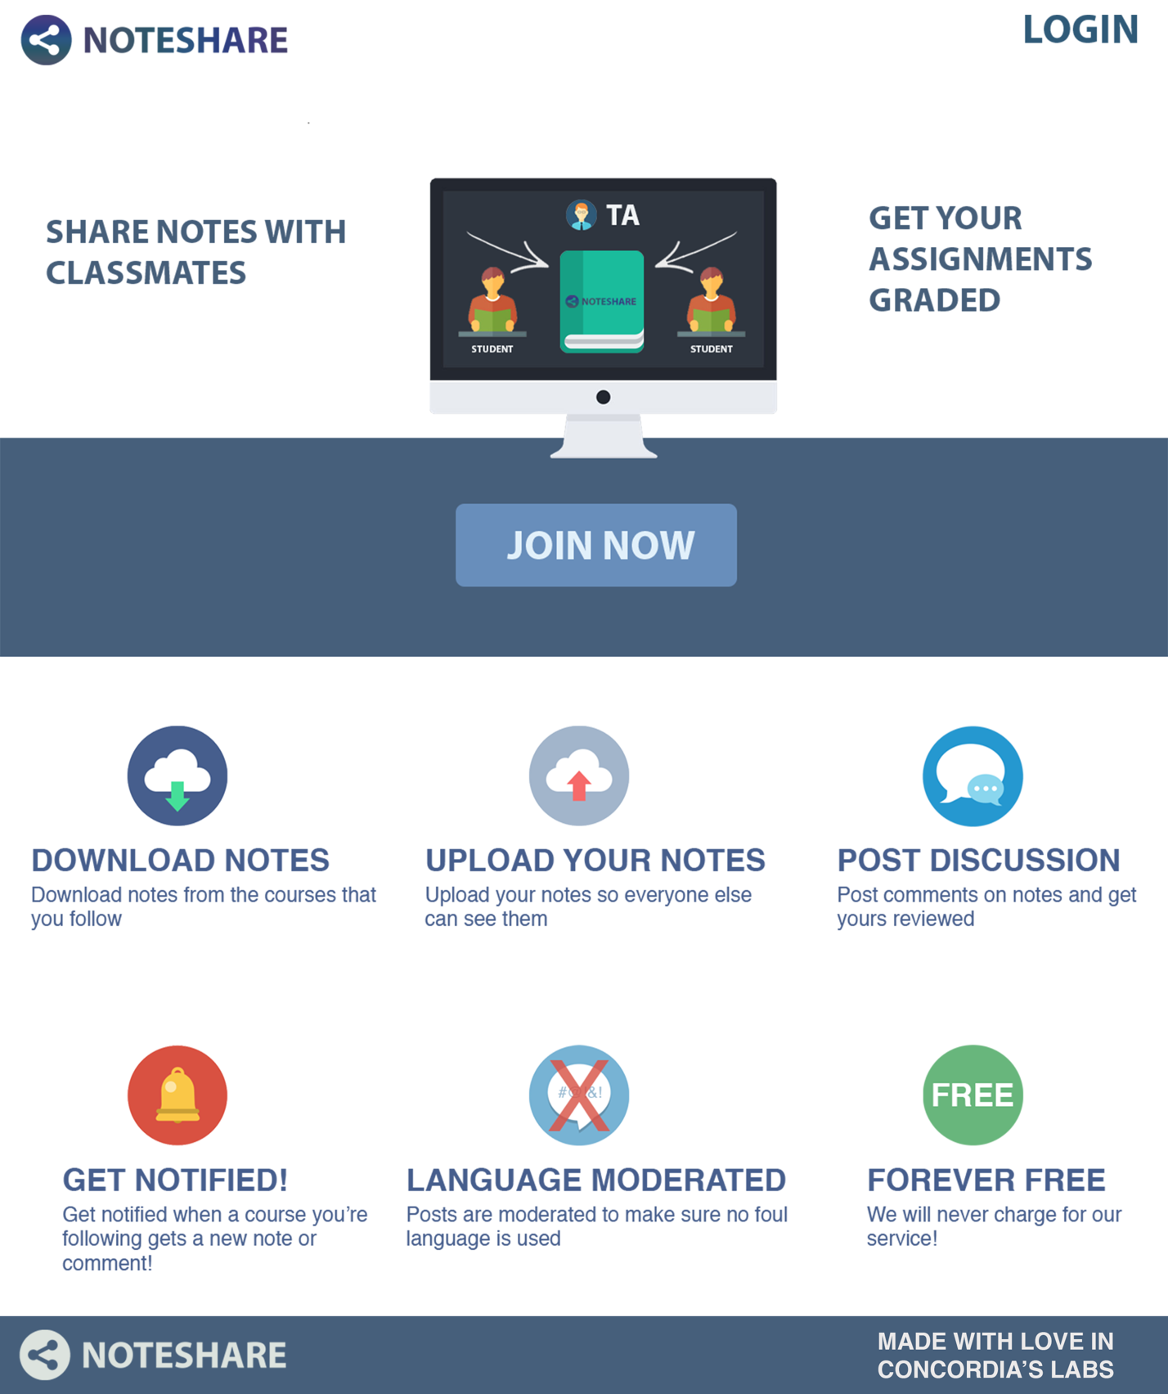

**February 12th, 2017**

Anthony: *I PUSHED ALL THE CHANGES I MADE.* I made a lot of changes to a lot of files. Please be very careful when you merge the changes into your branch. The possibility of a merge conflict is very high if you made any changes since your last pull request. *IF YOU GET A MERGE CONFLICT AT ANY POINT, CONTACT ME PLEASE.*

After the sprint everything was combined and a major update to the master branch.

**February 20th, 2017**

Adam shared a comment system mock up and received feedback on it.

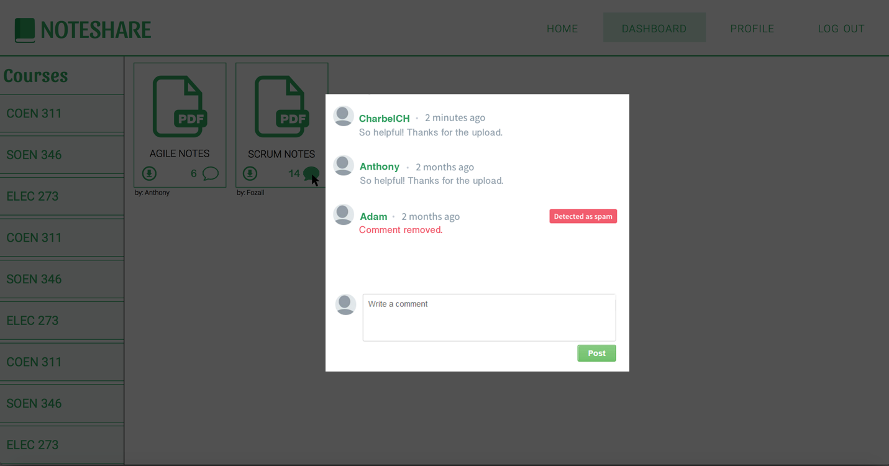

Anthony: It should say the name of the PDF you're commenting on, maybe at the top of the modal

Mohammed: Does it take the entire page, or does it show up in the center like that?

Charbel: The user should be able to view the document while reading the comments no? Instead of having to switch between the two or are we not displaying the pdf?

Anthony: It will take a lot of work to display the pdf alongside another html. If something wants to do it, we can save it for later sprints.

Adam: I’ll add the pdf name on top! Yeah it’ll popover when you click on the comment bubble

**February 23rd, 2017**

Anthony posted an update for the team:

Hey team, so I did a cool thing. I configured Travis CI to automatic deployment to Heroku when our build and tests pass. I’m not really going to try to explain what I did but basically our website is accessible to anyone that goes to this URL https://e-learning-noteshare.herokuapp.com/. I thought I should share this with you guys. Everything is fully functional except the fonts aren’t loading properly but we can fix that eventually.

**February 25th, 2017**

Daniel shared his implementation for the upload section, which he tried to make look like the mockup Adam shared made for the comments, with the team for their feedback. Adam and Anthony liked what they say. Moreover, Adam expressed how this’ll help him because he can reuse the popup for the comments when we add them to the dashboard.

**March 15th, 2017**

Anthony added a responsive bar for smaller screens for the website and requested all team members to review it.

**March 19th, 2017**

Daniel thought of a few user stories for our last sprint:

“We also have to consider that a significant part of the last sprint is testing so some people will be working on that. I figure these range from 2-8 story points, what do you all think? Note that we can take all, some or none of these depending on feedback”

Change the picture on the profile page based on type of account (2)

Toggle censoring the comments (could depend on implementation) (4)

Have a star system for the notes where you can award stars to notes you think are particularly good. (6)

A cart system to bulk download notes (8)

Also worth noting is we still have to do notifications when a new note is posted which is 9 points.

Anthony shared:

I’m thinking more along the lines of:

- Being able to delete courses you belong to

- Begin able to rename documents you posted

- We can have a unit testing story

We can change the profile icon depending on the account type sure.

**March 23rd, 2017**

Anthony:

Hey Team! I just pushed my massive reorganization of the repo. You can *try to merge into your branch* but you may *get merge conflicts*. If you do, type ‘git merge –abort’ go back to master and just *create a new branch* (once on master do: ‘git checkout -b branch-name’). I also added a reset script which you can run by typing ‘npm run reset’. This will reset all the database tables and delete all the pdfs you uploaded automatically. This is useful during development and testing. I CHANGED A LOT OF FILES so its very possible I made a mistake somewhere. Test the website out, if you find any bugs let me know asap. I just want to say good work everyone, it was a productive sprint! See you all Friday.

**March 24th, 2017**

Okay so it turns out we *need* a unit test for everyone story. Will post a detailed description of the tests everyone will write soon.

**March 25th, 2017**

Anthony Posted the Unit Tests Checklist and shared some information with the team.

Team please try to start on these *as early as possible*. Writing these unit tests is like learning a whole new language. The earlier you start; the earlier I can provide assistance. Were so close to the finish line. Thanks!

Pushed a view bug fixes, notably:

- there was a reloading issue on comments modal

- fixed the eslint config file

- added the feature the ta requested: check if the course is actually a course in the database

*make sure you pull these changes before proceeding with your user stories*

Also, to be able to use the ‘jest’ command from the terminal you may need to do the follow command: ‘npm install -g jest jest-cli’